Egov-HRMS Testing after version upgrade

- Count : http://localhost:9999/egov-hrms/employees/_count?tenantId=pg.citya&_=1751966362253

Payload :-
curl --location 'http://localhost:9999/egov-hrms/employees/_count?tenantId=pg.citya&_=1751966362253' \
--header 'accept: application/json, text/plain, */*' \
--header 'accept-language: en-US,en;q=0.9' \
--header 'content-type: application/json;charset=UTF-8' \
--header 'origin: https://niuatt.niua.in' \
--header 'priority: u=1, i' \
--header 'referer: https://niuatt.niua.in/digit-ui/employee' \
--header 'sec-ch-ua: "Not)A;Brand";v="8", "Chromium";v="138", "Google Chrome";v="138"' \
--header 'sec-ch-ua-mobile: ?0' \
--header 'sec-ch-ua-platform: "Linux"' \
--header 'sec-fetch-dest: empty' \
--header 'sec-fetch-mode: cors' \
--header 'sec-fetch-site: same-origin' \
--header 'user-agent: Mozilla/5.0 (X11; Linux x86_64) AppleWebKit/537.36 (KHTML, like Gecko) Chrome/138.0.0.0 Safari/537.36' \
--data '{
"RequestInfo": {
"apiId": "Rainmaker",
"authToken": "111910a1-9140-455a-8527-79f079a18429",
"userInfo": {
"id": 802,
"uuid": "29f36e66-da1f-43fb-907c-391adee2fff2",
"userName": "HRMS2",
"name": "OK",
"mobileNumber": "9999900032",
"emailId": null,
"locale": null,
"type": "EMPLOYEE",
"roles": [
{
"name": "Employee",
"code": "EMPLOYEE",
"tenantId": "pg.citya"
},
{
"name": "HRMS ADMIN",
"code": "HRMS_ADMIN",
"tenantId": "pg.citya"
}
],
"active": true,
"tenantId": "pg.citya",
"permanentCity": null
},
"msgId": "1751966362252|en_IN",
"plainAccessRequest": {}
}
}'

Response:
{
"ResponseInfo": {
"apiId": null,
"ver": null,
"ts": null,
"resMsgId": "uief87324",
"msgId": null,
"status": "successful"
},
"EmployeCount": {
"totalEmployee": "175",
"activeEmployee": "75",
"inactiveEmployee": "100"
}
}

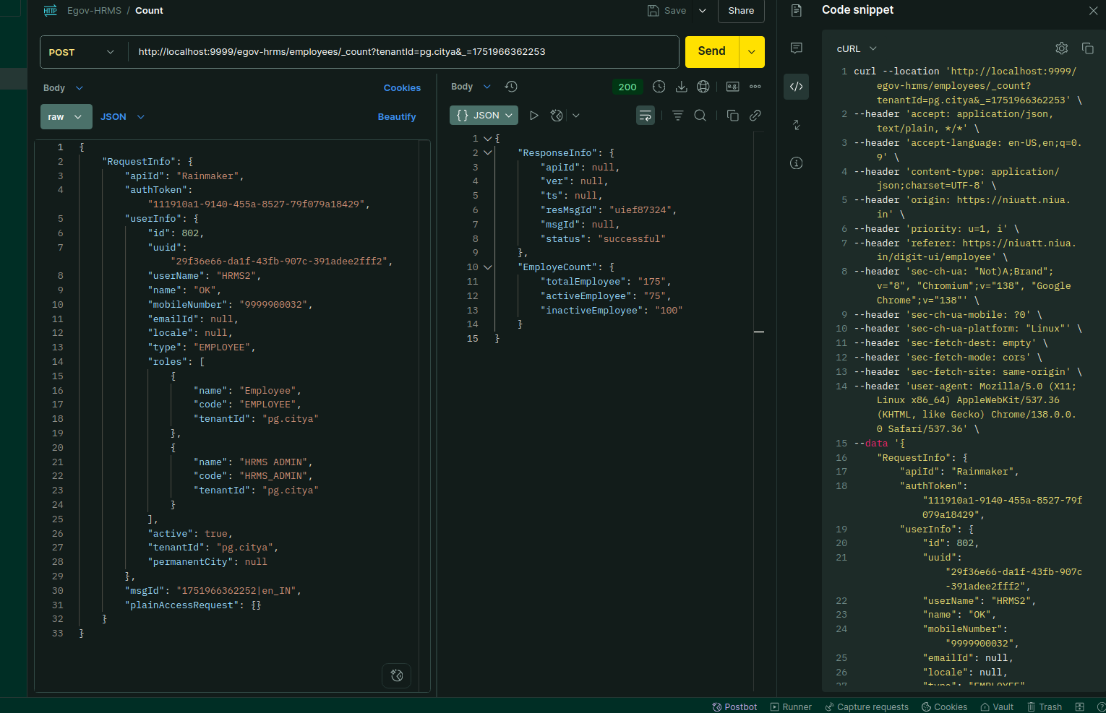

Environment via port-forward:

Response:
{
"ResponseInfo": {
"apiId": null,
"ver": null,
"ts": null,
"resMsgId": "uief87324",
"msgId": null,
"status": "successful"
},
"EmployeCount": {
"totalEmployee": "175",
"activeEmployee": "75",
"inactiveEmployee": "100"
}
}

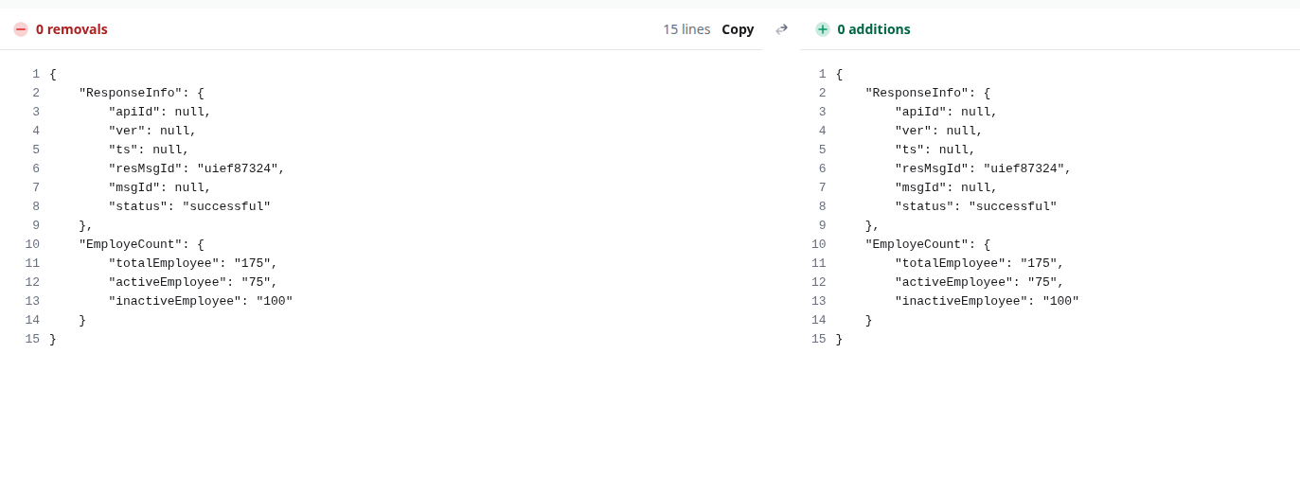

- Search: http://localhost:9999/egov-hrms/employees/_search?tenantId=pg.citya&_=1751966362253&codes=SV_CEMP

Payload Curl:-
curl --location 'http://localhost:9999/egov-hrms/employees/_search?tenantId=pg.citya&_=1751966362253&codes=SV_CEMP' \
--header 'accept: application/json, text/plain, */*' \
--header 'accept-language: en-US,en;q=0.9' \
--header 'content-type: application/json;charset=UTF-8' \
--header 'origin: https://niuatt.niua.in' \
--header 'priority: u=1, i' \
--header 'referer: https://niuatt.niua.in/digit-ui/employee' \
--header 'sec-ch-ua: "Not)A;Brand";v="8", "Chromium";v="138", "Google Chrome";v="138"' \
--header 'sec-ch-ua-mobile: ?0' \
--header 'sec-ch-ua-platform: "Linux"' \
--header 'sec-fetch-dest: empty' \
--header 'sec-fetch-mode: cors' \
--header 'sec-fetch-site: same-origin' \
--header 'user-agent: Mozilla/5.0 (X11; Linux x86_64) AppleWebKit/537.36 (KHTML, like Gecko) Chrome/138.0.0.0 Safari/537.36' \
--data '{
"RequestInfo": {
"apiId": "Rainmaker",
"authToken": "111910a1-9140-455a-8527-79f079a18429",
"userInfo": {
"id": 802,
"uuid": "29f36e66-da1f-43fb-907c-391adee2fff2",
"userName": "HRMS2",
"name": "OK",
"mobileNumber": "9999900032",
"emailId": null,
"locale": null,
"type": "EMPLOYEE",
"roles": [
{
"name": "Employee",
"code": "EMPLOYEE",
"tenantId": "pg.citya"
},
{
"name": "HRMS ADMIN",
"code": "HRMS_ADMIN",
"tenantId": "pg.citya"
}
],
"active": true,
"tenantId": "pg.citya",
"permanentCity": null
},
"msgId": "1751966362252|en_IN",
"plainAccessRequest": {}
}
}'

Response:-
{
"ResponseInfo": {
"apiId": "Rainmaker",
"ver": null,
"ts": null,
"resMsgId": "uief87324",
"msgId": "1751966362252|en_IN",
"status": "successful"
},
"Employees": [
{
"id": 295,
"uuid": "a82d1005-32a8-4038-a016-7154a9f0a162",
"code": "SV_CEMP",
"employeeStatus": "EMPLOYED",
"employeeType": "PERMANENT",
"dateOfAppointment": 1728086400000,
"jurisdictions": [
{
"id": "a57f8a2d-4b33-4db7-afea-663b7c6cdf03",
"hierarchy": "ADMIN",
"boundary": "pg.citya",
"boundaryType": "City",
"tenantId": "pg.citya",
"auditDetails": {
"createdBy": "34841137-d97e-4075-a664-3e563e329d7f",
"createdDate": 1729665771927,
"lastModifiedBy": null,
"lastModifiedDate": 0
},
"isActive": true
}
],
"assignments": [
{
"id": "510edb92-7633-4625-be60-8be2ffa27cd8",
"position": 78,
"designation": "DESIG_01",
"department": "DEPT_18",
"fromDate": 1728086400000,
"toDate": null,
"govtOrderNumber": null,
"tenantid": "pg.citya",
"reportingTo": null,
"auditDetails": {
"createdBy": "34841137-d97e-4075-a664-3e563e329d7f",
"createdDate": 1729665771927,
"lastModifiedBy": null,
"lastModifiedDate": 0
},
"isHOD": false,
"isCurrentAssignment": true
}
],
"serviceHistory": [],
"education": [],
"tests": [],
"tenantId": "pg.citya",
"documents": [],
"deactivationDetails": [],
"reactivationDetails": [],
"auditDetails": {
"createdBy": "34841137-d97e-4075-a664-3e563e329d7f",
"createdDate": 1729665771927,
"lastModifiedBy": null,
"lastModifiedDate": 0
},
"reActivateEmployee": false,
"user": null,
"isActive": false
}
]
}

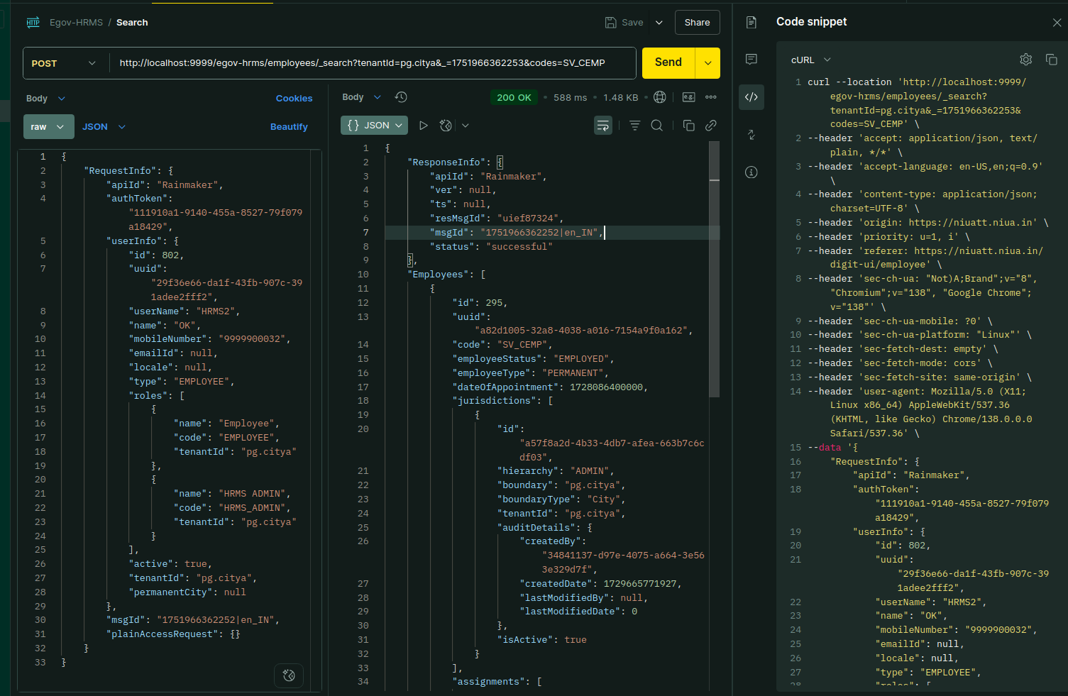

Environment via port-forward:

Response:
{
"ResponseInfo": {
"apiId": "Rainmaker",
"ver": null,
"ts": null,
"resMsgId": "uief87324",
"msgId": "1751966362252|en_IN",
"status": "successful"
},
"Employees": [
{
"id": 295,
"uuid": "a82d1005-32a8-4038-a016-7154a9f0a162",
"code": "SV_CEMP",
"employeeStatus": "EMPLOYED",
"employeeType": "PERMANENT",
"dateOfAppointment": 1728086400000,
"jurisdictions": [
{
"id": "a57f8a2d-4b33-4db7-afea-663b7c6cdf03",
"hierarchy": "ADMIN",
"boundary": "pg.citya",
"boundaryType": "City",
"tenantId": "pg.citya",
"auditDetails": {
"createdBy": "34841137-d97e-4075-a664-3e563e329d7f",
"createdDate": 1729665771927,
"lastModifiedBy": null,
"lastModifiedDate": 0
},
"isActive": true
}
],
"assignments": [
{
"id": "510edb92-7633-4625-be60-8be2ffa27cd8",
"position": 78,
"designation": "DESIG_01",
"department": "DEPT_18",
"fromDate": 1728086400000,
"toDate": null,
"govtOrderNumber": null,
"tenantid": "pg.citya",
"reportingTo": null,
"auditDetails": {
"createdBy": "34841137-d97e-4075-a664-3e563e329d7f",
"createdDate": 1729665771927,
"lastModifiedBy": null,
"lastModifiedDate": 0
},
"isHOD": false,
"isCurrentAssignment": true
}
],
"serviceHistory": [],
"education": [],
"tests": [],
"tenantId": "pg.citya",
"documents": [],
"deactivationDetails": [],
"reactivationDetails": [],
"auditDetails": {
"createdBy": "34841137-d97e-4075-a664-3e563e329d7f",
"createdDate": 1729665771927,
"lastModifiedBy": null,
"lastModifiedDate": 0
},
"reActivateEmployee": false,
"user": null,
"isActive": false
}
]
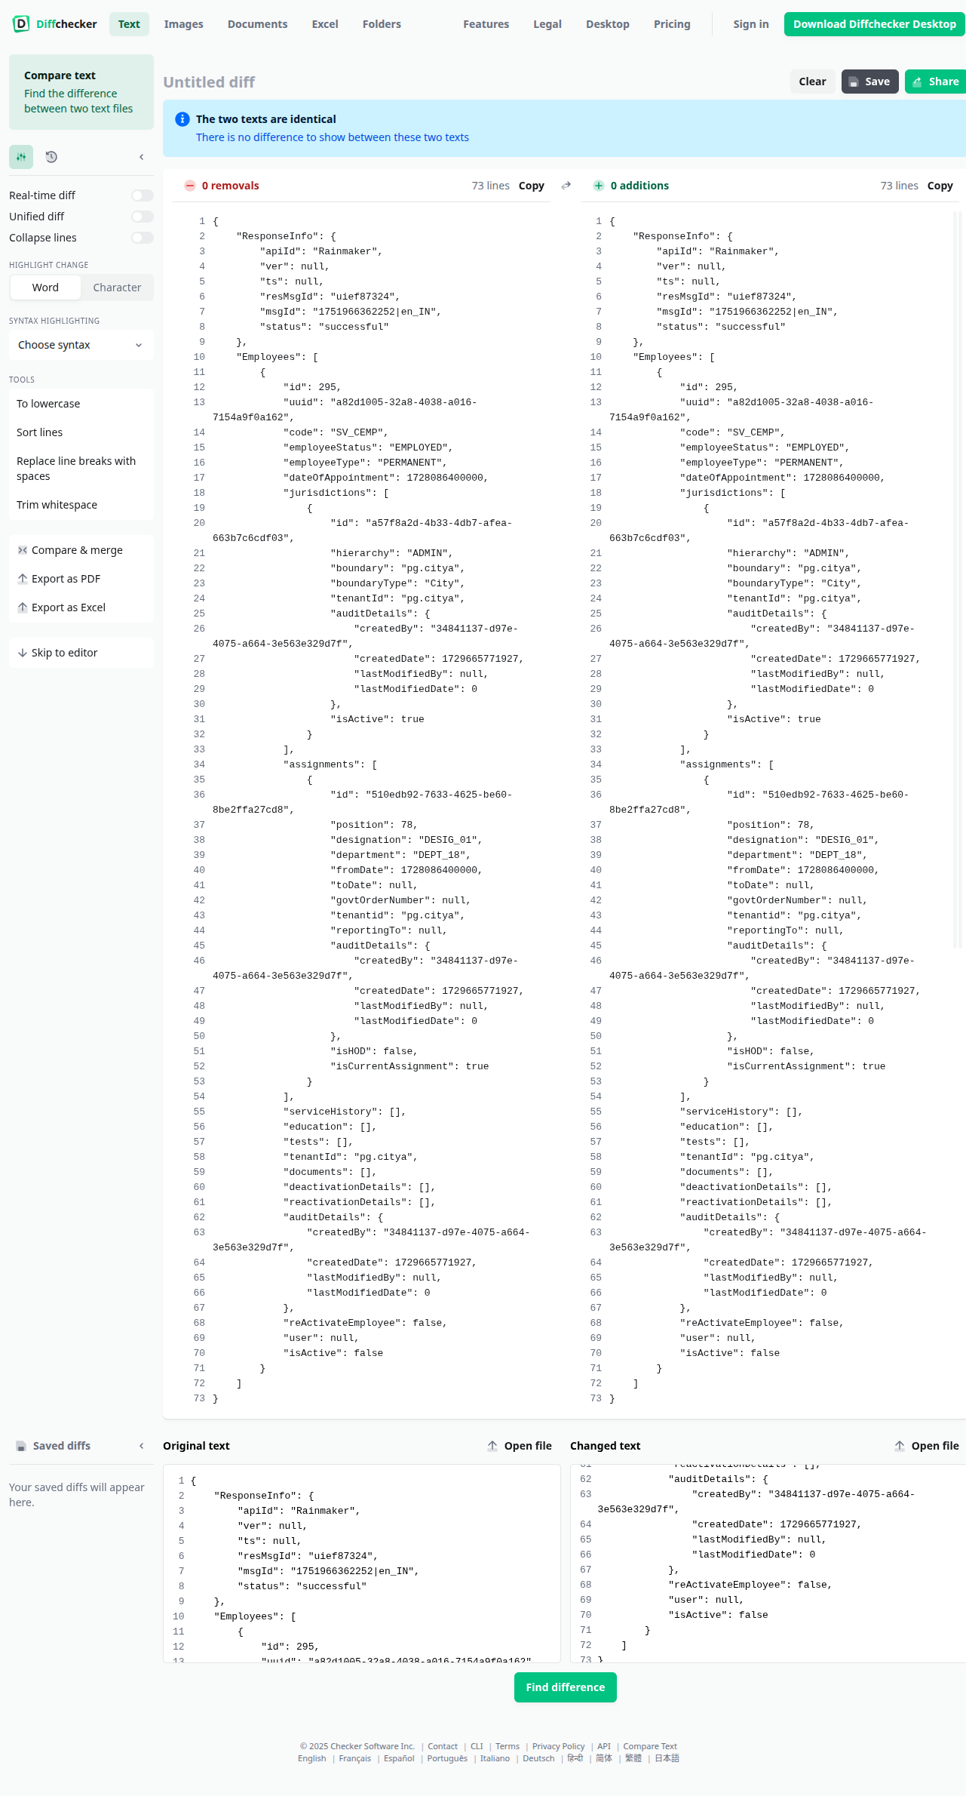
}

- Create :https://niuatt.niua.in/egov-hrms/employees/_create?tenantId=pg.citya&_=1751971156038

Payload Curl -
curl --location 'http://localhost:9999/egov-hrms/employees/_create?tenantId=pg.citya&_=1751971156038' \
--header 'accept: application/json, text/plain, */*' \
--header 'accept-language: en-US,en;q=0.9' \
--header 'content-type: application/json;charset=UTF-8' \
--header 'origin: https://niuatt.niua.in' \
--header 'priority: u=1, i' \
--header 'referer: https://niuatt.niua.in/digit-ui/employee/hrms/response' \
--header 'sec-ch-ua: "Not)A;Brand";v="8", "Chromium";v="138", "Google Chrome";v="138"' \
--header 'sec-ch-ua-mobile: ?0' \
--header 'sec-ch-ua-platform: "Linux"' \
--header 'sec-fetch-dest: empty' \
--header 'sec-fetch-mode: cors' \
--header 'sec-fetch-site: same-origin' \
--header 'user-agent: Mozilla/5.0 (X11; Linux x86_64) AppleWebKit/537.36 (KHTML, like Gecko) Chrome/138.0.0.0 Safari/537.36' \
--data '{
"Employees": [
{
"tenantId": "pg.citya",
"employeeStatus": "EMPLOYED",
"assignments": [
{
"fromDate": 1751587200000,
"isCurrentAssignment": true,
"department": "DEPT_3",
"designation": "DESIG_03"
}
],
"code": "EMP_45",
"dateOfAppointment": 1751500800000,
"employeeType": "PERMANENT",
"jurisdictions": [
{
"hierarchy": "ADMIN",
"boundaryType": "City",
"boundary": "pg.citya",
"tenantId": "pg.citya",
"roles": [
{
"code": "EMPLOYEE",
"name": "Employee",
"labelKey": "ACCESSCONTROL_ROLES_ROLES_EMPLOYEE",
"tenantId": "pg.citya"
}
]
}
],
"user": {
"mobileNumber": "7777777777",
"name": "Sourabh",
"correspondenceAddress": "delhi",
"gender": "MALE",
"dob": 931046400000,
"roles": [
{
"code": "EMPLOYEE",
"name": "Employee",
"labelKey": "ACCESSCONTROL_ROLES_ROLES_EMPLOYEE",
"tenantId": "pg.citya"
}
],
"tenantId": "pg.citya"
},
"serviceHistory": [],
"education": [],
"tests": []
}
],
"key": "CREATE",
"action": "CREATE",
"RequestInfo": {
"apiId": "Rainmaker",
"authToken": "111910a1-9140-455a-8527-79f079a18429",
"userInfo": {
"id": 802,
"uuid": "29f36e66-da1f-43fb-907c-391adee2fff2",
"userName": "HRMS2",
"name": "OK",
"mobileNumber": "9999900032",
"emailId": null,
"locale": null,
"type": "EMPLOYEE",
"roles": [
{
"name": "Employee",
"code": "EMPLOYEE",
"tenantId": "pg.citya"
},
{
"name": "HRMS ADMIN",
"code": "HRMS_ADMIN",
"tenantId": "pg.citya"
}
],
"active": true,
"tenantId": "pg.citya",
"permanentCity": null
},
"msgId": "1751971156038|en_IN",
"plainAccessRequest": {}
}
}'

Response:
{
"ResponseInfo": {
"apiId": "Rainmaker",
"ver": null,
"ts": null,
"resMsgId": "uief87324",
"msgId": "1751971156038|en_IN",
"status": "successful"
},
"Employees": [
{
"id": -92592657183980478,
"uuid": "feb70b78-07bd-4442-9c0a-0a87c2e07ad8",
"code": "EMP_45",
"employeeStatus": "EMPLOYED",
"employeeType": "PERMANENT",
"dateOfAppointment": 1751500800000,
"jurisdictions": [
{
"id": "a75e5fb5-4e59-4095-aa81-2ec5b3428062",
"hierarchy": "ADMIN",
"boundary": "pg.citya",
"boundaryType": "City",
"tenantId": "pg.citya",
"auditDetails": {
"createdBy": "29f36e66-da1f-43fb-907c-391adee2fff2",
"createdDate": 1751972469823,
"lastModifiedBy": null,
"lastModifiedDate": null
},
"isActive": true
}
],
"assignments": [
{
"id": "67ff5e93-208b-489c-b482-c2aba5fdea97",
"position": 235,
"designation": "DESIG_03",
"department": "DEPT_3",
"fromDate": 1751587200000,
"toDate": null,
"govtOrderNumber": null,
"tenantid": null,
"reportingTo": null,
"auditDetails": {
"createdBy": "29f36e66-da1f-43fb-907c-391adee2fff2",
"createdDate": 1751972469823,
"lastModifiedBy": null,
"lastModifiedDate": null
},
"isHOD": false,
"isCurrentAssignment": true
}
],
"serviceHistory": [],
"education": [],
"tests": [],
"tenantId": "pg.citya",
"documents": [],
"deactivationDetails": [],
"reactivationDetails": [],
"auditDetails": {
"createdBy": "29f36e66-da1f-43fb-907c-391adee2fff2",
"createdDate": 1751972469823,
"lastModifiedBy": null,
"lastModifiedDate": null
},
"reActivateEmployee": null,
"user": {
"id": 3839,
"uuid": "feb70b78-07bd-4442-9c0a-0a87c2e07ad8",
"userServiceUuid": null,
"userName": "EMP_45",
"password": null,
"salutation": null,
"name": "Sourabh",
"gender": "MALE",
"mobileNumber": "7777777777",
"emailId": null,
"altContactNumber": null,
"pan": null,
"aadhaarNumber": null,
"permanentAddress": null,
"permanentCity": null,
"permanentPinCode": null,
"correspondenceCity": null,
"correspondencePinCode": null,
"correspondenceAddress": "delhi",
"active": true,
"dob": 931046400000,
"pwdExpiryDate": null,
"locale": null,
"type": "EMPLOYEE",
"signature": null,
"accountLocked": null,
"roles": [
{
"name": "Employee",
"code": "EMPLOYEE",
"description": null,
"tenantId": "pg.citya"
}
],
"fatherOrHusbandName": null,
"relationship": null,
"bloodGroup": null,
"identificationMark": null,
"photo": null,
"createdBy": null,
"createdDate": null,
"lastModifiedBy": null,
"lastModifiedDate": null,
"otpReference": null,
"tenantId": "pg.citya",
"rowVersion": null
},
"isActive": true
}
]
}

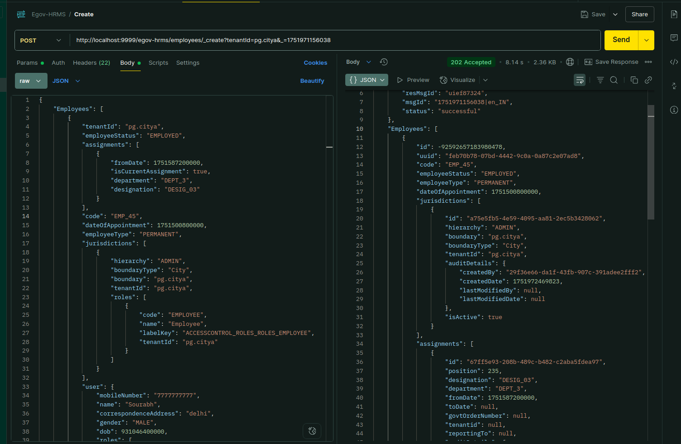

Environment via port-forward:

Response:
{
"ResponseInfo": {
"apiId": "Rainmaker",
"ver": null,
"ts": null,
"resMsgId": "uief87324",
"msgId": "1751971156038|en_IN",
"status": "successful"
},
"Employees": [
{
"id": 3840,
"uuid": "f792003c-1dc6-41d8-9034-463ecd970575",
"code": "EMP_46",
"employeeStatus": "EMPLOYED",
"employeeType": "PERMANENT",
"dateOfAppointment": 1751500800000,
"jurisdictions": [
{
"id": "404a7388-d282-4d6a-8e9c-72bf6f80cba9",
"hierarchy": "ADMIN",
"boundary": "pg.citya",
"boundaryType": "City",
"tenantId": "pg.citya",
"auditDetails": {
"createdBy": "29f36e66-da1f-43fb-907c-391adee2fff2",
"createdDate": 1751972601658,
"lastModifiedBy": null,
"lastModifiedDate": null
},
"isActive": true
}
],
"assignments": [
{
"id": "c8374c45-4b9a-45c4-a91e-d180cf3e43ef",
"position": 236,
"designation": "DESIG_03",
"department": "DEPT_3",
"fromDate": 1751587200000,
"toDate": null,
"govtOrderNumber": null,
"tenantid": null,
"reportingTo": null,
"auditDetails": {
"createdBy": "29f36e66-da1f-43fb-907c-391adee2fff2",
"createdDate": 1751972601658,
"lastModifiedBy": null,
"lastModifiedDate": null
},
"isHOD": false,
"isCurrentAssignment": true
}
],
"serviceHistory": [],
"education": [],
"tests": [],
"tenantId": "pg.citya",
"documents": [],
"deactivationDetails": [],
"reactivationDetails": [],
"auditDetails": {
"createdBy": "29f36e66-da1f-43fb-907c-391adee2fff2",
"createdDate": 1751972601658,
"lastModifiedBy": null,
"lastModifiedDate": null
},
"reActivateEmployee": null,
"user": {
"id": 3840,
"uuid": "f792003c-1dc6-41d8-9034-463ecd970575",
"userName": "EMP_46",
"password": null,
"salutation": null,
"name": "Sourabh",
"gender": "MALE",
"mobileNumber": "7777777772",
"emailId": null,
"altContactNumber": null,
"pan": null,
"aadhaarNumber": null,
"permanentAddress": null,
"permanentCity": null,
"permanentPinCode": null,
"correspondenceCity": null,
"correspondencePinCode": null,
"correspondenceAddress": "delhi",
"active": true,
"dob": 931046400000,
"pwdExpiryDate": null,
"locale": null,
"type": "EMPLOYEE",
"signature": null,
"accountLocked": null,
"roles": [
{
"name": "Employee",
"code": "EMPLOYEE",
"description": null,
"tenantId": "pg.citya"
}
],
"fatherOrHusbandName": null,
"relationship": null,
"bloodGroup": null,
"identificationMark": null,
"photo": null,
"createdBy": null,
"createdDate": null,
"lastModifiedBy": null,
"lastModifiedDate": null,
"otpReference": null,
"tenantId": "pg.citya"
},
"isActive": true
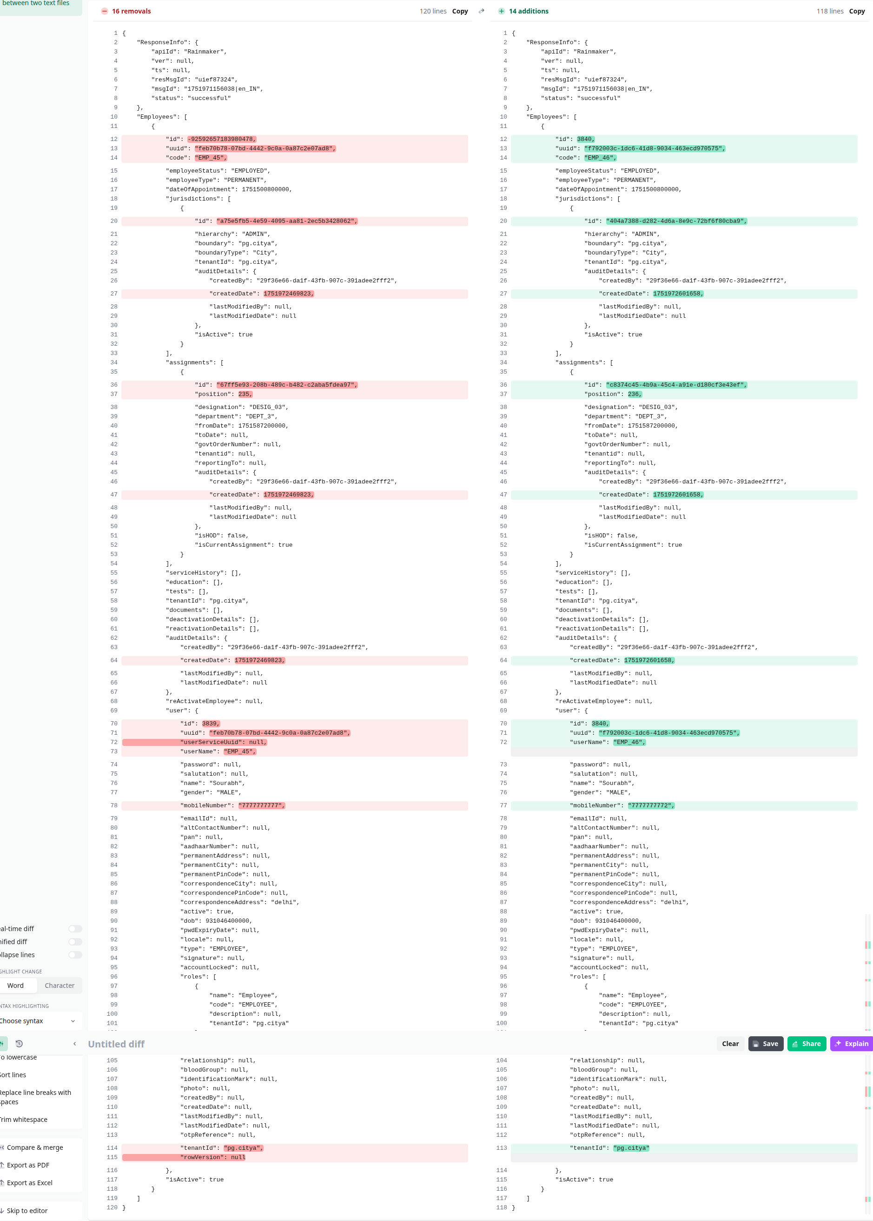
} ]}

-Update:

Payload -curl:
curl --location 'https://niuatt.niua.in/egov-hrms/employees/_update?tenantId=pg.citya&_=1751971288500' \
--header 'accept: application/json, text/plain, */*' \
--header 'accept-language: en-US,en;q=0.9' \
--header 'content-type: application/json;charset=UTF-8' \
--header 'origin: https://niuatt.niua.in' \
--header 'priority: u=1, i' \
--header 'referer: https://niuatt.niua.in/digit-ui/employee/hrms/response' \
--header 'sec-ch-ua: "Not)A;Brand";v="8", "Chromium";v="138", "Google Chrome";v="138"' \
--header 'sec-ch-ua-mobile: ?0' \
--header 'sec-ch-ua-platform: "Linux"' \
--header 'sec-fetch-dest: empty' \
--header 'sec-fetch-mode: cors' \
--header 'sec-fetch-site: same-origin' \
--header 'user-agent: Mozilla/5.0 (X11; Linux x86_64) AppleWebKit/537.36 (KHTML, like Gecko) Chrome/138.0.0.0 Safari/537.36' \
--data '{
"Employees": [
{
"id": 3838,
"uuid": "2199b3cb-0362-4d46-8219-9f3834e88aad",
"code": "EMP_44",
"employeeStatus": "EMPLOYED",
"employeeType": "PERMANENT",
"dateOfAppointment": 1751500800000,
"jurisdictions": [
{
"id": "52a5b715-fadb-4dda-8f51-20ff2c72141f",
"hierarchy": "ADMIN",
"boundaryType": "City",
"boundary": "pg.citya",
"tenantId": "pg.citya",
"auditDetails": {
"createdBy": "29f36e66-da1f-43fb-907c-391adee2fff2",
"createdDate": 1751971157279,
"lastModifiedDate": 0
},
"roles": [
{
"name": "Employee",
"code": "EMPLOYEE",
"tenantId": "pg.citya",
"labelKey": "ACCESSCONTROL_ROLES_ROLES_EMPLOYEE"
}
]
}
],
"assignments": [
{
"id": "7b3a9550-3445-4d0b-92ca-c58f1be75f27",
"position": 234,
"tenantid": "pg.citya",
"auditDetails": {
"createdBy": "29f36e66-da1f-43fb-907c-391adee2fff2",
"createdDate": 1751971157279,
"lastModifiedDate": 0
},
"fromDate": 1751587200000,
"isCurrentAssignment": true,
"department": "DEPT_3",
"designation": "DESIG_03"
}
],
"serviceHistory": [],
"education": [],
"tests": [],
"tenantId": "pg.citya",
"documents": [],
"deactivationDetails": [],
"reactivationDetails": [],
"auditDetails": {
"createdBy": "29f36e66-da1f-43fb-907c-391adee2fff2",
"createdDate": 1751971157279,
"lastModifiedBy": null,
"lastModifiedDate": 0
},
"reActivateEmployee": false,
"user": {
"id": 3838,
"uuid": "2199b3cb-0362-4d46-8219-9f3834e88aad",
"userName": "EMP_44",
"password": null,
"salutation": null,
"name": "Sourabh",
"gender": "MALE",
"mobileNumber": "7777777771",
"altContactNumber": null,
"pan": null,
"aadhaarNumber": null,
"permanentAddress": null,
"permanentCity": null,
"permanentPinCode": null,
"correspondenceCity": null,
"correspondencePinCode": null,
"correspondenceAddress": "delhi",
"active": true,
"dob": 931046400000,
"pwdExpiryDate": 1759747157000,
"locale": null,
"type": "EMPLOYEE",
"signature": null,
"accountLocked": false,
"roles": [
{
"name": "Employee",
"code": "EMPLOYEE",
"tenantId": "pg.citya",
"labelKey": "ACCESSCONTROL_ROLES_ROLES_EMPLOYEE"
}
],
"fatherOrHusbandName": null,
"relationship": null,
"bloodGroup": null,
"identificationMark": null,
"photo": null,
"createdBy": "802",
"createdDate": 1751971157000,
"lastModifiedBy": "802",
"lastModifiedDate": 1751971157000,
"otpReference": null,
"tenantId": "pg.citya"
},
"isActive": true
}
],
"RequestInfo": {
"apiId": "Rainmaker",
"authToken": "111910a1-9140-455a-8527-79f079a18429",
"userInfo": {
"id": 802,
"uuid": "29f36e66-da1f-43fb-907c-391adee2fff2",
"userName": "HRMS2",
"name": "OK",
"mobileNumber": "9999900032",
"emailId": null,
"locale": null,
"type": "EMPLOYEE",
"roles": [
{
"name": "Employee",
"code": "EMPLOYEE",
"tenantId": "pg.citya"
},
{
"name": "HRMS ADMIN",
"code": "HRMS_ADMIN",
"tenantId": "pg.citya"
}
],
"active": true,
"tenantId": "pg.citya",
"permanentCity": null
},
"msgId": "1751971288500|en_IN",
"plainAccessRequest": {}
}
}'

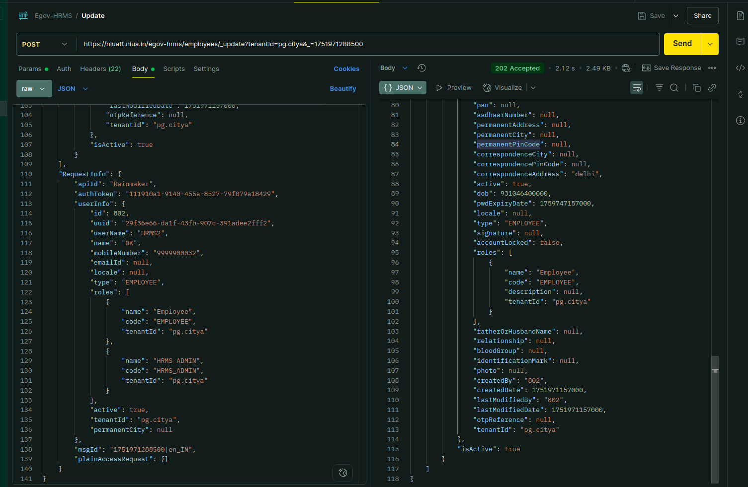

Response:
{
"ResponseInfo": {
"apiId": "Rainmaker",
"ver": null,
"ts": null,
"resMsgId": "uief87324",
"msgId": "1751971288500|en_IN",
"status": "successful"
},
"Employees": [
{
"id": 3838,
"uuid": "2199b3cb-0362-4d46-8219-9f3834e88aad",
"code": "EMP_44",
"employeeStatus": "EMPLOYED",
"employeeType": "PERMANENT",
"dateOfAppointment": 1751500800000,
"jurisdictions": [
{
"id": "52a5b715-fadb-4dda-8f51-20ff2c72141f",
"hierarchy": "ADMIN",
"boundary": "pg.citya",
"boundaryType": "City",
"tenantId": "pg.citya",
"auditDetails": {
"createdBy": "29f36e66-da1f-43fb-907c-391adee2fff2",
"createdDate": 1751971157279,
"lastModifiedBy": null,
"lastModifiedDate": 0
},
"isActive": true
}
],
"assignments": [
{
"id": "7b3a9550-3445-4d0b-92ca-c58f1be75f27",
"position": 234,
"designation": "DESIG_03",
"department": "DEPT_3",
"fromDate": 1751587200000,
"toDate": null,
"govtOrderNumber": null,
"tenantid": "pg.citya",
"reportingTo": null,
"auditDetails": {
"createdBy": "29f36e66-da1f-43fb-907c-391adee2fff2",
"createdDate": 1751971157279,
"lastModifiedBy": null,
"lastModifiedDate": 0
},
"isHOD": false,
"isCurrentAssignment": true
}
],
"serviceHistory": [],
"education": [],
"tests": [],
"tenantId": "pg.citya",
"documents": [],
"deactivationDetails": [],
"reactivationDetails": [],
"auditDetails": {
"createdBy": "29f36e66-da1f-43fb-907c-391adee2fff2",
"createdDate": 1751971157279,
"lastModifiedBy": null,
"lastModifiedDate": 0
},
"reActivateEmployee": false,
"user": {
"id": 3838,
"uuid": "2199b3cb-0362-4d46-8219-9f3834e88aad",
"userName": "EMP_44",
"password": null,
"salutation": null,
"name": "Sourabh",
"gender": "MALE",
"mobileNumber": "7777777771",
"emailId": null,
"altContactNumber": null,
"pan": null,
"aadhaarNumber": null,
"permanentAddress": null,
"permanentCity": null,
"permanentPinCode": null,
"correspondenceCity": null,
"correspondencePinCode": null,
"correspondenceAddress": "delhi",
"active": true,
"dob": 931046400000,
"pwdExpiryDate": 1759747157000,
"locale": null,
"type": "EMPLOYEE",
"signature": null,
"accountLocked": false,
"roles": [
{
"name": "Employee",
"code": "EMPLOYEE",
"description": null,
"tenantId": "pg.citya"
}
],
"fatherOrHusbandName": null,
"relationship": null,
"bloodGroup": null,
"identificationMark": null,
"photo": null,
"createdBy": "802",
"createdDate": 1751971157000,
"lastModifiedBy": "802",
"lastModifiedDate": 1751971157000,
"otpReference": null,
"tenantId": "pg.citya"
},
"isActive": true
}
]
}

Environment via Port-forward:

Response:

{
"ResponseInfo": {
"apiId": "Rainmaker",
"ver": null,
"ts": null,
"resMsgId": "uief87324",
"msgId": "1751971288500|en_IN",
"status": "successful"
},
"Employees": [
{
"id": 3838,
"uuid": "2199b3cb-0362-4d46-8219-9f3834e88aad",
"code": "EMP_44",
"employeeStatus": "EMPLOYED",
"employeeType": "PERMANENT",
"dateOfAppointment": 1751500800000,
"jurisdictions": [
{
"id": "52a5b715-fadb-4dda-8f51-20ff2c72141f",
"hierarchy": "ADMIN",
"boundary": "pg.citya",
"boundaryType": "City",
"tenantId": "pg.citya",
"auditDetails": {
"createdBy": "29f36e66-da1f-43fb-907c-391adee2fff2",
"createdDate": 1751971157279,
"lastModifiedBy": null,
"lastModifiedDate": 0
},
"isActive": true
}
],
"assignments": [
{
"id": "7b3a9550-3445-4d0b-92ca-c58f1be75f27",
"position": 234,
"designation": "DESIG_03",
"department": "DEPT_3",
"fromDate": 1751587200000,
"toDate": null,
"govtOrderNumber": null,
"tenantid": "pg.citya",
"reportingTo": null,
"auditDetails": {
"createdBy": "29f36e66-da1f-43fb-907c-391adee2fff2",
"createdDate": 1751971157279,
"lastModifiedBy": null,
"lastModifiedDate": 0
},
"isHOD": false,
"isCurrentAssignment": true
}
],
"serviceHistory": [],
"education": [],
"tests": [],
"tenantId": "pg.citya",
"documents": [],
"deactivationDetails": [],
"reactivationDetails": [],
"auditDetails": {
"createdBy": "29f36e66-da1f-43fb-907c-391adee2fff2",
"createdDate": 1751971157279,
"lastModifiedBy": null,
"lastModifiedDate": 0
},
"reActivateEmployee": false,
"user": {
"id": 3838,
"uuid": "2199b3cb-0362-4d46-8219-9f3834e88aad",
"userName": "EMP_44",
"password": null,
"salutation": null,
"name": "Sourabh",
"gender": "MALE",
"mobileNumber": "7777777771",
"emailId": null,
"altContactNumber": null,
"pan": null,
"aadhaarNumber": null,
"permanentAddress": null,
"permanentCity": null,
"permanentPinCode": null,
"correspondenceCity": null,
"correspondencePinCode": null,
"correspondenceAddress": "delhi",
"active": true,
"dob": 931046400000,
"pwdExpiryDate": 1759747157000,
"locale": null,
"type": "EMPLOYEE",
"signature": null,
"accountLocked": false,
"roles": [
{
"name": "Employee",
"code": "EMPLOYEE",
"description": null,
"tenantId": "pg.citya"
}
],
"fatherOrHusbandName": null,
"relationship": null,
"bloodGroup": null,
"identificationMark": null,
"photo": null,
"createdBy": "802",
"createdDate": 1751971157000,
"lastModifiedBy": "802",
"lastModifiedDate": 1751971157000,
"otpReference": null,
"tenantId": "pg.citya"
},
"isActive": true
}
]



